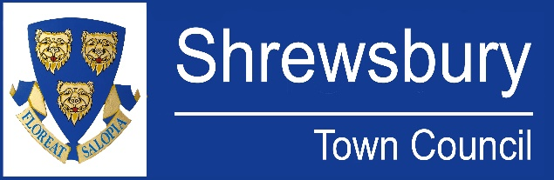

Communications Officer

37 hours per week

J7, SCP 18 – 23, £29,269 - £32,076 (pay award pending)

We are seeking a Communications Officer to help us connect with our residents! Shrewsbury Town Council are committed to enhancing the quality of life for our community through engagement and innovative communication strategies.

The individual will deliver and evaluate all the Town Council’s communications activities in order to engage residents, local community groups, businesses, partner organisations, and the media.

Proven experience in communications with strong organisational skills are essential as is the ability to foster a positive workplace culture.

The post holder will show flexibility in their workload and be committed to working outside core hours to meet the demands of the service.

If you’re excited about shaping the future of communication in our town, we want to hear from you -please complete an application form at: www.shrewsburytowncouncil.gov.uk

For an informal chat, please contact Helen Ball (helen.ball@shrewsburytowncouncil.gov.uk)

Closing Date for applications – midday Friday 8th November 2024
Interviews – mid / late November 2024

